Steven Gibson

EC1521948

H17Y 34 Systems Foundations

Table of Contents

**Task 1** 2

**Task 2** 2

**Task 3** 3

**Task 4** 5

All code is suppled in its own text document

# **Task 1 (code is in task1.asm)**



Figure 1 Task 1 output

# **Task 2 (code is in task2.asm)**

Output for “:”

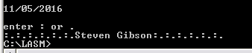

Figure 2 Task 2 output

Output for “.”

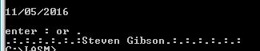

Figure Task 2 additional output

# **Task 3 (code is in task3.asm)**

Output for “4 and (“

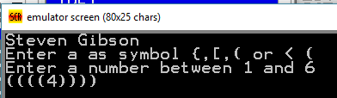

Figure Task 3 Output

Output for “3 and [“

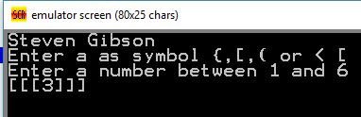

Figure Task 3 Output

Output for “2 and {“

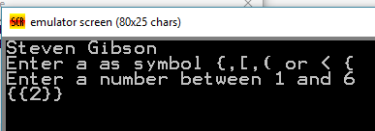

Figure Task 3 Output

Output for “6 and <“

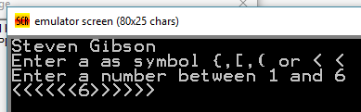

Figure Task 3 Output

Output for “6 and @“ (*any other character on the keyboard will give this screen*)

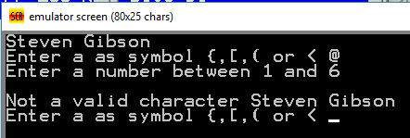

Figure Task 3 Output

# **Task 4 (code is in task4.asm)**

Output for “6 and (“  
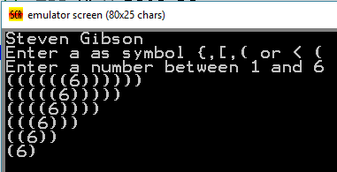

Figure Task 4 Output

Output for “2 and [“  
 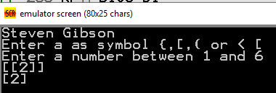

Figure Task 4 Output

Output for “4 and {“  
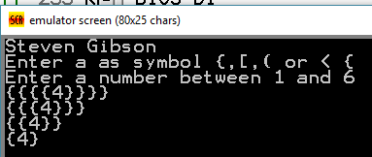

Figure Task 4 Output

Output for “5 and <“  
 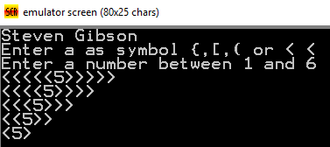

Figure Task 4 Output

Output for “1 and P“(*any other character on the keyboard will give this screen*)  
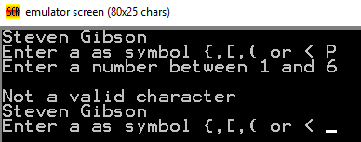

Figure Task 4 Output